**Level 1: PC Tower Case**

**Outline**

Learn about the internals of a standard PC case by examining physical samples and selecting and labeling images found on-line. Gain deeper knowledge by researching and reporting on specific components.

**Questions**

1. Find one (or more) images that clearly show the internals of a PC Tower Case.   
   (i.e. Google images using keywords “PC Case Internals”)  
   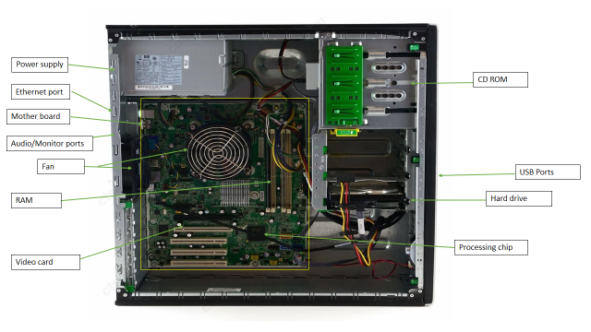
2. Clearly label the following components (using arrows) on your image of the PC case internals:
   1. Motherboard
   2. Power Supply
   3. Hard Disk Drive
   4. Optical Disk Drive (e.g.DVD)
   5. USB Expansion Ports
   6. Monitor Port
   7. Audio Ports
   8. Ethernet Port
   9. Cooling Fan

(labeled using different words)

1. Research more in-depth about “Motherboards”. Make notes on the following:
   1. What different versions are currently available (speed and capacity)

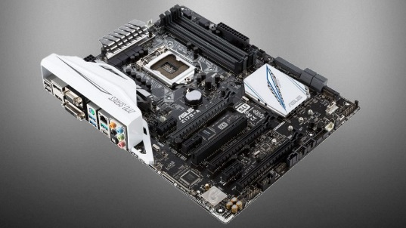

Typically 64 GB of RAM storage, with multiple USB ports and high end processing chips. These motherboards are often $175+ depending on how many additional parts there are that aren’t needed. These are usually gaming motherboards that involve more extra parts. Simple motherboards look the same but aren’t as flashy as gaming motherboards but they can run the same applications as a standard computer.

* 1. How the component has changed since the 1980’s  
     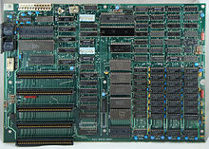

In 1980, motherboard designs were not as advanced as 2018 motherboards. If you compare the two motherboards, the 2018 ones are priced over $150 typically because of how much more they have to offer. 1980 computer motherboards don’t include as much storage as 2018 motherboards and they didn’t have some of the ports we have today such as HDMI ports. The layout and look was advanced in the 80’s but if we compare it with 2018 motherboards, it seems like a simple design to us.

1. Research more in-depth about “Hard Disk Drives”. Make notes on the following:
   1. What different versions are currently available (speed and capacity)

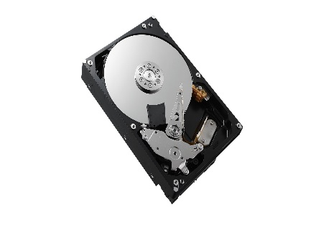

Depending on the price of the disk drive, you can get 500GB of storage or over 5 TB. Most are fast spinning disk drives and some have cooling fans attached to them. Disk drives are found in different devices. You can have them in your computer, or a slimmer one in a laptop or even a gaming system.

* 1. How the component has changed since the 1980’s  
     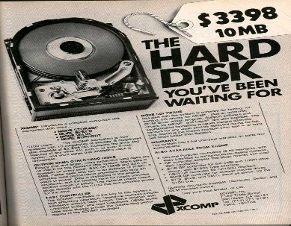

1980 disc drives were extremely expensive probably because this was new technology as there were cassette tapes and drives. This meant that the price was high and overpriced. The design and build was also unique as it was really bulky and was shaped as a typically larger box. For something that bulky, it also had minimal storage. Today, we have slimmer disk drives with a lot more storage.

**Level 2: PC Motherboard**

**Outline**

Learn about the structure of a standard PC motherboard by examining physical samples and selecting and labeling images found on-line. Gain deeper knowledge by researching and reporting on specific components.

**Questions**

1. Find one (or more) images that clearly show the layout of a PC Motherboard.   
   (i.e. Google images using keywords “PC Motherboard”)

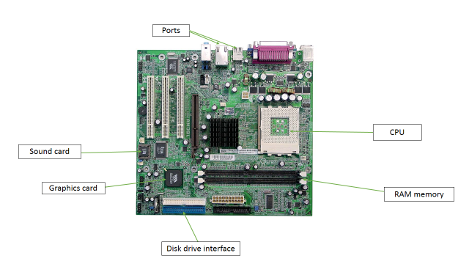

1. Clearly label the following components (using arrows) on your image of the PC motherboard:
   1. CPU (and fan)
   2. RAM Memory
   3. Disk Drive Interface (IDE or SATA)
   4. GPU Graphics Processor (either on-board or Graphics Card)
   5. Sound Processor (either on-board or Sound Card)
   6. Wi-Fi / Ethernet Network Interface (either on-board or Graphics Card)

1. Research more in-depth about “CPU Processor Chip”. Make notes on the following:
   1. What different versions are currently available (speed and capacity)

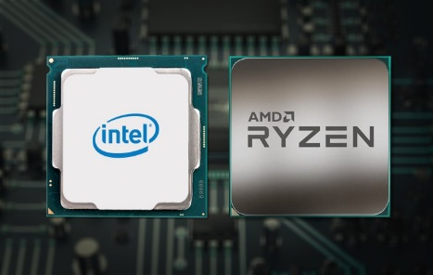

Small and compact chips that have more cores and thread and higher base clock and boost clock. Prices for high end chips are extremely expensive. For a high end cpu chip, $400-500 is considered average. Newer chips can hold and withstand different files or images that older chips may not be able to run.

* 1. How the component has changed since the 1980’s  
     in the 80’s, the chips were a lot bigger in size and didn’t have high speeds or a good amount of cores and threads compared to modern chips. Chips were probably more expensive or around the same price because computers were considered to be high end and there weren’t as much models in the 80’s compared to how much we have today.

1. Research more in-depth about “RAM Memory”. Make notes on the following:
   1. What different versions are currently available (speed and capacity)

Modern RAM memory cards hold a lot of files depending on the number of cards you have. they include high MHz speeds and an average high end RAM memory card costs between $100-250.

* 1. How the component has changed since the 1980’s  
     in the 80’s, RAM memory cards didn’t hold as much and were expensive. In the 80’s, a 4 MB RAM memory was considered a lot and were between $100-200.

**Level 3: Peripheral Devices**

**Outline**

Learn about how peripheral devices are connected to the back side of a typical PC tower case. Examine physical samples, select and labeling images found on-line and gain deeper knowledge by researching and reporting on specific components.

**Questions**

1. Find one (or more) images that clearly show the layout of the back of a typical PC tower case.   
   (i.e. Google images using keywords “Back Of PC Tower”)  
   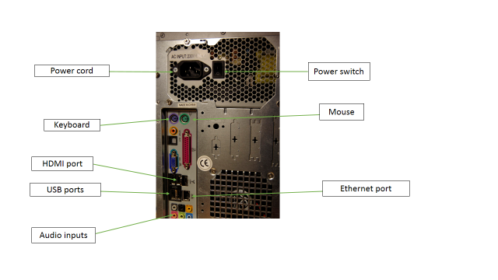
2. Clearly label the following components (using arrows) on your image of the back of a typical PC tower case:
   1. Power cord and power switch
   2. Monitor Interface (VGA or DVI or HDMI)
   3. Mouse Interface (USB or PS/2)
   4. Keyboard Interface (USB or PS/2)
   5. USB Ports
   6. Audio Inputs / Outputs
   7. Ethernet Interface

1. Research more in-depth about “Monitor Technology”. Make notes on the following:
   1. What different versions are currently available (e.g. VGA / DVI, Flat Panel Technology))

In 2018, you can buy multiple different designs for PC tower cases. High end tower cases could be clear with light up parts visible to someone looking at it or it could be a simple tower case that has the basic input and output devices necessary.

* 1. How the component has changed since the 1980’s (e.g. Display Resolution, Technology)

1. Research more in-depth about “External Portable Storage”. Make notes on the following:
   1. Floppy Disks

* A hardware device that reads and writes storage information
* Original floppy disks released in the 70’s were typically 8 inches
* Built into the computer case
  1. CD-ROM / DVD / Recordable CD/DVD
* A CD is an optical device that holds storage such as audio or video
  + A CD ROM is the device used to read those files
* CD ROM speed ranges from 1x-72X
  + 72x runs 72 times faster than 1x
  1. USB Memory Drives
* USB stick
* Drive connects to the computer allowing it to access the files
* First flash drives were 8 mb
  + Newer ones can be up to 2 tb
  1. Compact Flash Memory
* Most commonly used for storing photos or music
* Originally stored mb, newer ones store gb or tb
* Type I and type II. Type II is bigger in size and storage and costs more
  1. Cloud Based Storage
* Holds storage over the internet that can be accessed anywhere on a device with internet access
* Can hold a good amount of storage and no payment is needed
* Ex. Google drive

**Level 4: PC Component Presentation**

**Outline**

Explore the development and features of a specific PC hardware component through deeper research and investigation. Work in partners to create a short presentation. Deliver the presentation to the class.

Each group will research a unique PC hardware component . Your specific topic will be assigned from the list provided below.

**Presentation Structure**

1. **Explain what the PC component does and how it fits together with other components to make up a fully functioning PC.**without the monitor, the use wouldn’t be able to see what they are doing
2. **Explain how the PC component works. Provide a diagram (image) showing the main parts of the component.**
3. **Research the current state of the art of the component in terms speed, capacity (size), and other related factors.**
4. **Research on-line suppliers that sell the PC Component. List the specifications for the available products and the cost (price).**
5. **Research how the PC component has changed and evolved since the early days of PCs in the 1980’s. Cover each of the following topics separately:**
   1. **Component Speed**
   2. **Component Size / Capacity**
   3. **Two other specifications specific to the PC component (ask Mr. Nestor)**

**PC Component Topics**

|  |  |  |
| --- | --- | --- |
| **Topic** | **Partner 1** | **Partner 2** |
| CPU Microprocessor Chip |  |  |
| Motherboard Layout |  |  |
| Computer Graphics |  |  |
| Sound & Audio |  |  |
| Hard Disk Drives |  |  |
| Removable Disk Storage |  |  |
| Network / Internet Connectivity |  |  |
| Mouse / Pointing Devices |  |  |
| **Monitor & Display Technology** |  |  |
| Printers & Output Technology |  |  |